**BIQU 3D printer**

**common Q&A**

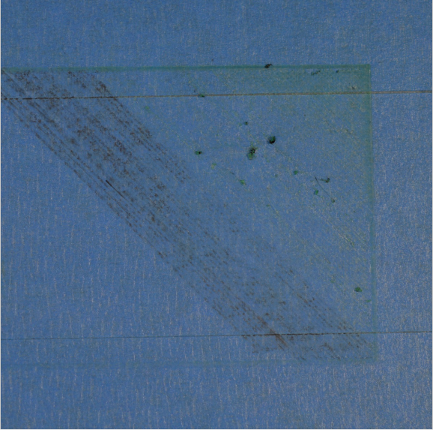

**Q:After printing, the material is not extruded.**

**A:**

1. Before printing, the extruder does not load consumables.

Found replacement supplies on the touch screen.

2.The nozzle is too close to the platform.

(First let's go back to the origin of the machine. Then with a piece of A4 paper in between the platform and nozzle, (0.16 -- 0.25 mm between the thickness of the A4 paper we print set when the initial layer is generally 0.2) move the print head back and forth to adjust bolt near twitch A4 paper fine-tuning adjustment bolt to adjust the platform an analogy, move the print head to other adjustment bolt to adjust the platform nearby.)

3.The line slipped on the extrusion gear

3D printer, through a pinion, to push wire forward or backward. The teeth on the gear bite into the line to precisely control the position of the line.It can be solved by increasing the temperature by 5 ~ 10 °.

4.The extruder is blocked

First of all, the temperature of the nozzle rises to 230-250 ℃. Then use fine needle to dredge the nozzle repeatedly from bottom to top. After cleaning, extrude the material. See if consumables flow out normally.

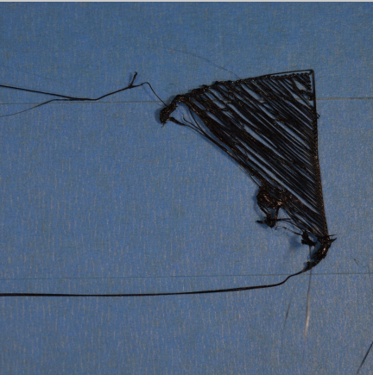

Q:Printed consumables cannot be attached to the platform

1. Platform not level,Nozzle too far from platform.

You can adjust the platform according to the previous method.(First let's go back to the origin of the machine. Then with a piece of A4 paper in between the platform and nozzle, (0.16 -- 0.25 mm between the thickness of the A4 paper we print set when the initial layer is generally 0.2) move the print head back and forth to adjust bolt near twitch A4 paper fine-tuning adjustment bolt to adjust the platform an analogy, move the print head to other adjustment bolt to adjust the platform nearby.)

1. First floor printing too fast

You can set the speed of the first layer on the slicing software, and try to print the first layer half as fast as possible.

1. There is a problem with the hot bed temperature setting

Increase the temperature of the hot bed on the slicing software. If the temperature rise of the hot bed is not high, you can see whether the wire of the hot bed is connected well.

1. Platform surface treatment

Before printing, please check whether there is no dust, grease or the like on the platform. Using water or alcohol to clean up the platform will have a very different effect.

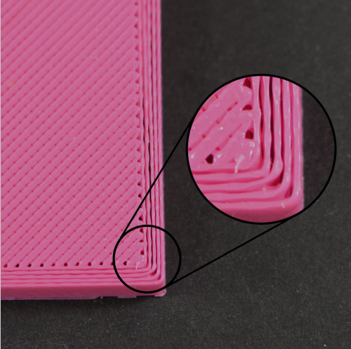

Q**：Insufficient discharge**

1. Incorrect wire diameter

You can view or modify the wire diameter in the software.

1. Increase extrusion ratio

You can adjust your basic rate in the slicing software to make him full.

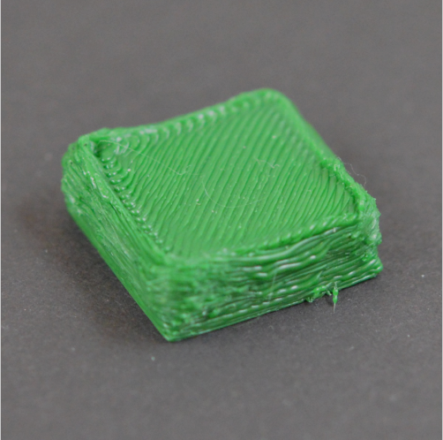

**Q:Excessive discharge**

1. You can reduce the extrusion ratio on the slicing software.

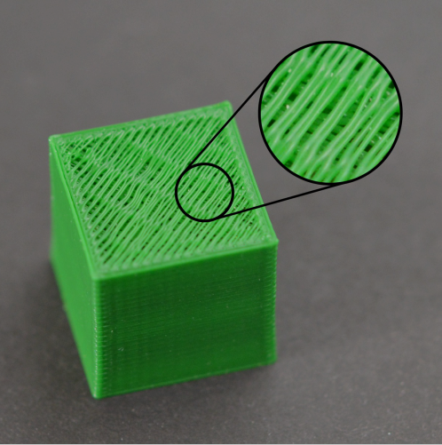

**Q:Holes or gaps in the top layer**

A:1.Insufficient top solid layers

On the slicing software, adjust the height parameters of the top layer and the bottom layer a little bit.

1. Fill rate too low

In the slicing software, the filling rate is increased.

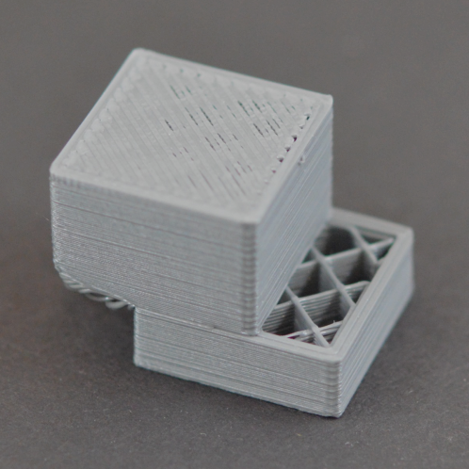

**Q:Layer dislocation**

1. Nozzle moves too fast

Adjust the "default printing speed" and "x / Y axis moving speed" in the slicing software. The default printing speed determines the speed at which the extrusion head extrudes the plastic. "X / Y axis movement speed" determines the movement speed when the print head is empty. If the speed is too fast, it may lead to dislocation.

1. Mechanical or electronic problems

Check the tightness of the timing belt and the timing wheel. Adjust to just the right tightness. If not, try updating the latest firmware. If not, please contact us.

**Q:Problems in printing when replacing other consumables**

A:1.The quality of consumables is poor, and new consumables need to be replaced.

2.The printing temperature drops properly.

**Q:Printer auto shutdown**

A:1.Slice error, gcode file is incomplete.

1. Try updating the latest firmware.

**Q:The machine cannot be heated.**

A :1.Motherboard short circuit

2.Check the plug cable to see if it is loose.

1. The heating rod line is loose.

**Q:Machine crash**

A:1.Replacement slice

2.Replacement SD card

1. Update Firmware

**Q:Motherboard overheating**

A:1.The wire is stuck and the fan doesn't turn.

1. The fan wires are connected reversely.
2. The cooling holes are blocked.

**Q:Mainboard cannot burn Marlin firmware**

A:1.Disconnect from the software.

1. My tool, disconnect.
2. Temporarily modify the wave frequency of the screen.
3. Physical disconnection: Unplug the connecting cable between the screen and the motherboard.

**Q:Touch screen doesn't work**

A:1.Remove the sheet metal and loosen the four screws slightly.

2.The blue and white lines on the screen are not in good contact.

1. Crash, determine if it's an SD card problem.